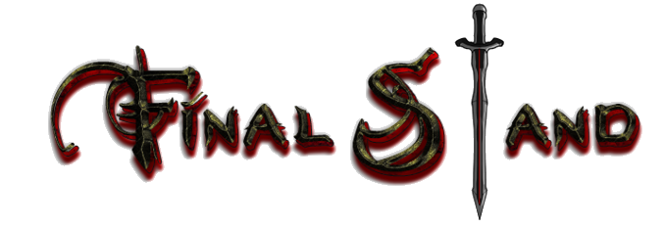

* Game objective: Defend our castle as long as possible in a tower defense style.
* To start:
  + Main menu
    - Help button
  + 1 endless level
    - Help button
  + 1 tutorial level?
    - Tips during game?
* 1 player-controlled character
  + Can traverse entire map
  + Attack with sword
    - Bow later?
  + Has health
    - On death he is stunned for 15-20 seconds?
    - Regains slowly over time after not being hit
* 1 end of map castle
  + Can upgrade with archers or other defenses?
  + Upgrade for more health?
* Towers:
  + Single attack:
    - Archer tower
  + Splash damage:
    - Catapult
  + Area affect:
    - Wizard tower
      * Speed other towers?
      * Slow enemies?
* Enemies:
  + Enemy king:
    - Boss
    - Most health
    - Entourage of weaker knights
  + Tanky Knight:
    - Medium health
    - Slow
  + Archer enemy:
    - Low health
    - fast